**TASK4**

**24K-0727 MUHAMMAD SAAD MASOOD**

**Q2**

**#include<stdio.h>**

**int main(){**

**int units;**

**float unit_price;**

**float bill;**

**printf("Enter the number of units consumed\n");**

**scanf("%d",&units);**

**if(units<=30){**

**bill=0.60*units+0.15*(units*unit_price);**

**printf("Rs %f",bill);**

**}**

**else if(units<=110){**

**bill=30*0.60+((units-30)*0.85)+0.15*(30*0.60+((units-30)*0.85));**

**printf("Rs %f",bill);**

**}**

**else if(units<=210){**

**bill=30*0.60+(80*0.85)+((units-110)*1.30)+0.15*(30*0.60+(80*0.85)+((units-110)*1.30));**

**printf("Rs %f",bill);**

**}**

**else if(units>210){**

**bill=30*0.60+(80*0.85)+(100*1.30)+((units-210)*1.60)+0.15*(30*0.60+(80*0.85)+(100*1.30)+((units-210)*1.60));**

**printf("Rs %f",bill);**

**}**

**}**

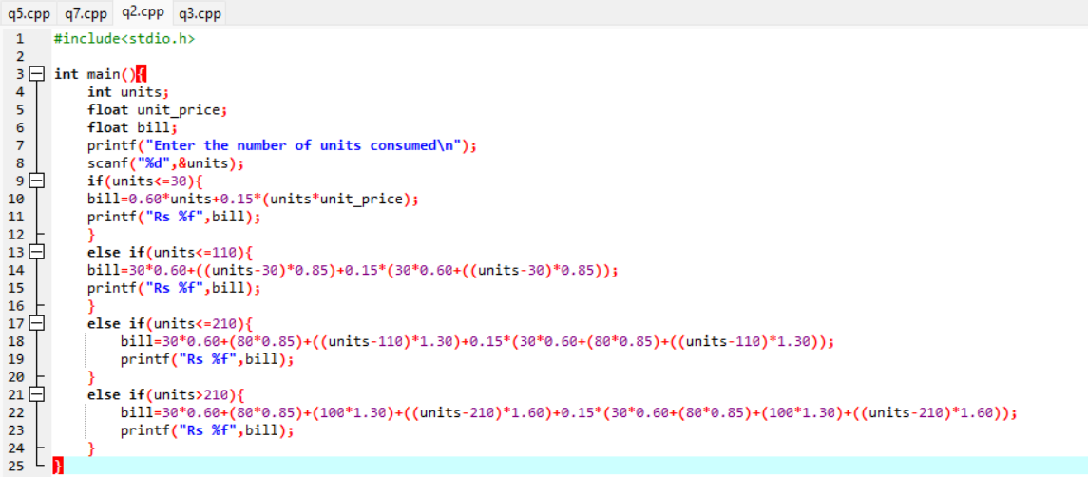

**Q3**

**#include<stdio.h>**

**int main(){**

**int original_amount;**

**float amount_saved;**

**float final_amount=original_amount-amount_saved;**

**printf("Enter original amount");**

**scanf("%d",&original_amount);**

**if(original_amount<1500){**

**amount_saved=0.07*original_amount;**

**final_amount=original_amount-amount_saved;**

**printf("%f",final_amount);**

**}**

**else if(1500<original_amount<3000){**

**amount_saved=0.12*original_amount;**

**final_amount=original_amount-amount_saved;**

**printf("%f",final_amount);**

**}**

**else if(3000<original_amount<5000){**

**amount_saved=0.22*original_amount;**

**final_amount=original_amount-amount_saved;**

**printf("%f",final_amount);**

**}**

**else if(original_amount>5000){**

**amount_saved=0.30*original_amount;**

**final_amount=original_amount-amount_saved;**

**printf("%f",final_amount);**

**}**

**}**

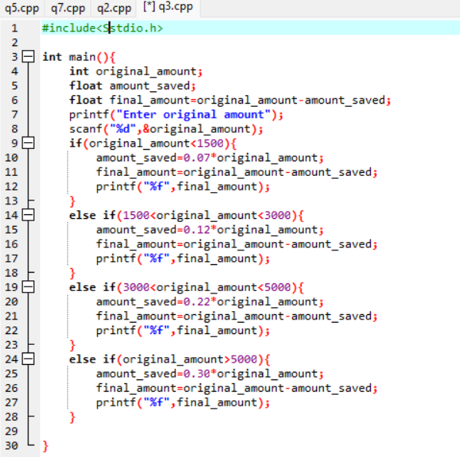

**Q5**

**#include<stdio.h>**

**int main(){**

**int time=0;**

**printf("Enter time in 24 hour format");**

**scanf("%d",&time);**

**switch(time){**

**case 0:**

**printf("Good Night");**

**break;**

**case 1:**

**printf("Good Night");**

**break;**

**case 2:**

**printf("Good Night");**

**break;**

**case 3:**

**printf("Good Night");**

**break;**

**case 4:**

**printf("Good Night");**

**break;**

**case 5:**

**printf("Good Night");**

**break;**

**case 6:**

**printf("Good Morning");**

**break;**

**case 7:**

**printf("Good Morning");**

**break;**

**case 8:**

**printf("Good Morning");**

**break;**

**case 9:**

**printf("Good Morning");**

**break;**

**case 10:**

**printf("Good Morning");**

**break;**

**case 11:**

**printf("Good Morning");**

**break;**

**case 12:**

**printf("Good Afternoon");**

**break;**

**case 13:**

**printf("Good Afternoon");**

**break;**

**case 14:**

**printf("Good Afternoon");**

**break;**

**case 15:**

**printf("Good Afternoon");**

**break;**

**case 16:**

**printf("Good Afternoon");**

**break;**

**case 17:**

**printf("Good Afternoon");**

**break;**

**case 18:**

**printf("Good Evening");**

**break;**

**case 19:**

**printf("Good Evening");**

**break;**

**case 20:**

**printf("Good Evening");**

**break;**

**case 21:**

**printf("Good Evening");**

**break;**

**case 22:**

**printf("Good Evening");**

**break;**

**case 23:**

**printf("Good Evening");**

**break;**

**default:**

**printf("Error");**

**}}**

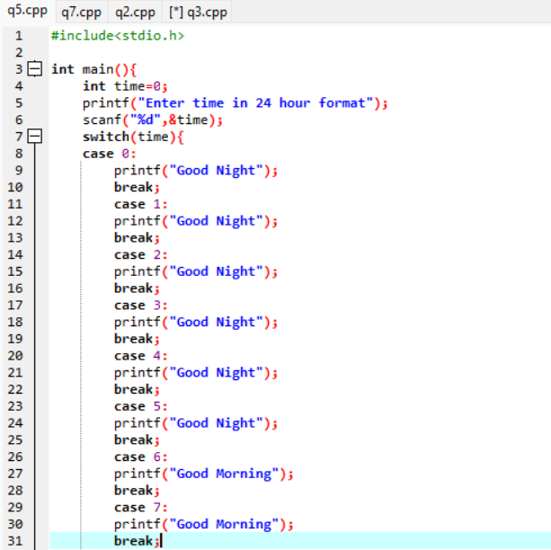

**Q7**

**#include<stdio.h>**

**int main(){**

**printf(" ------------\n");**

**printf(" / \\ \n");**

**printf(" / \\ \n");**

**printf(" / /\\_/\\ \\ \n");**

**printf(" / ( . . ) ^ \\ \n");**

**printf("| ) ( (( | \n");**

**printf(" \\ (> <)_)) / \n");**

**printf(" \\ ----- / \n");**

**printf(" \\ K24-0727 / \n");**

**printf(" \\ / \n");**

**printf(" ------------");**

**}**

